**Nama : Alessandro Pramudhita Putra Setyawan**

**Asal Sekolah : Universitas Gunadarma**

**Tugas 2**

**Listing Source Code**

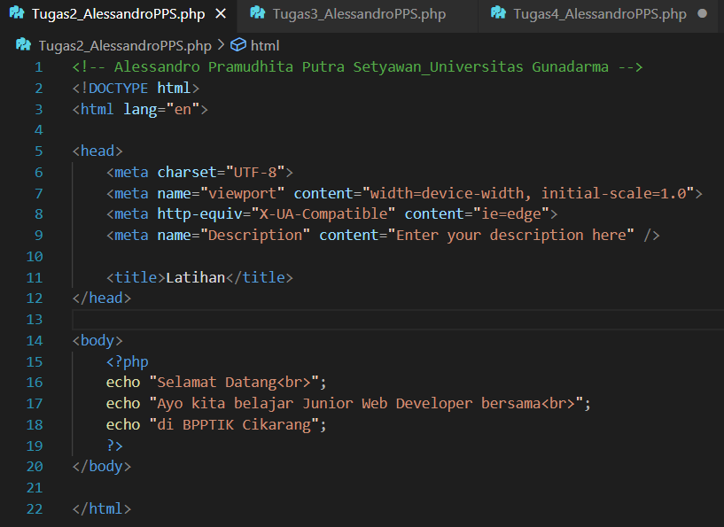

**Output Source Code**

